Equestrian Awards of the Knowne World
By Baroness Brenna MacGrioghair (2014)
Revision by Donwenna La Mareschale (2016)

Kingdom | Award Name | Requirements | Armigerous
West  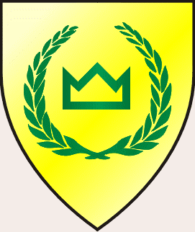 | The Order of the King’s Lance  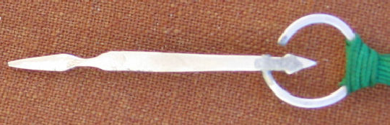 | Given to those who have shown excellence in and continued support of the equestrian arts. The token is a silver lance suspended from a ribbon. | No
 | The Order of the Western Gold Scarf  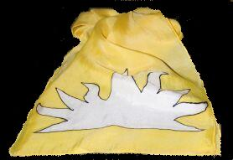 | Membership in this order is granted to those who excel in the practice, study, and teaching of the equestrian arts of peace and/or of war. Members of the order serve as exemplars of the West Kingdom's equestrian might and earn the title of "Rider of the West". The token of membership in this order is a gold scarf bearing a white demi-sun. | Grant of Arms
East  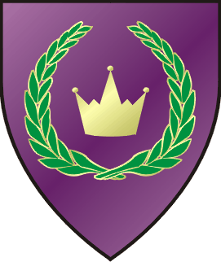 | Order of the Golden Lance | Given for prowess in the equestrian lists and service to the Kingdom in marshalling, teaching, and helping to promote and expand the knowledge of equestrian arts. Established March 28, A.S. 49 by Edward III and Thyra II. | Grant of Arms
Atenveldt  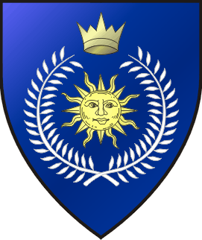 | The Order of the White Stirrup  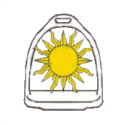 | Given by the Crown to those equestrians who have given service to the equestrian arts in the Kingdom of Atenveldt. This order shall consist of three levels and the award is suspended from a colored ribbon denoting the level: Blue ribbon (first level), Silver or white ribbon (second level), Gold or yellow ribbon (third level). The members of this Order shall be styled as Companions of the White Stirrup and shall be entitled place the initials C.W.S. after their names. The insignia of the order, (Fieldless) A sun Or within and conjoined to a stirrup Argent. | No
 | The Order of the Black Chamfron  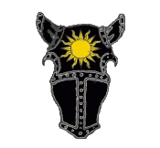 | There shall exist in the Kingdom of Atenveldt an award, known as the Order of the Black Chamfron which may be given by the Crown to those persons who have demonstrated excellence and skill on the Equestrian tournament field and in the Equestrian Arts. These equestrians have also distinguished themselves in demonstrating leadership, honor on and off the equestrian tournament field; knowledge and practice of the courtly graces; consistent service to the Kingdom; and who have shown respect for the laws and customs of the Kingdom of Atenveldt. The members of the Order shall be styled as Companions of the Black Chamfron and shall be entitled to place the initials C.B.C. after their names. The insignia of the Order shall consist of a (Fieldless) A chamfron Sable charged with a sun Or. The Order shall carry with it a Grant of Arms. | Grant of Arms
Middle  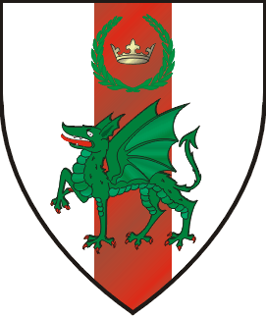 | Order of the White Lance   | Given to individuals who, in the sight of the Crown, have shown excellence in two of three areas of equestrian activities; skill, service and the arts and sciences. Holders of the Order shall be entitled to place after their names the initials, C.W.L. and may be styled and announced in precedence as Companion of the White Lance. | Grant of Arms
 | Order of the White Chamfron | Given to individuals who, in the sight of the Crown, have shown proficiency on the field of equestrian activities or exemplary service in furthering such field. Holders of the Order shall be entitled to place after their names the initials C.W.C., and may be styled and announced in precedence as Companions of the Order of the White Chamfron. | Award of Arms
Caid  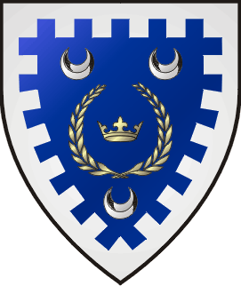 | The Order of the Chamfron   | The Chamfron is awarded for superior skill and authenticity in appearance in equestrian activities. Azure, on a chamfron argent, a crescent azure, all within a bordure embattled argent. | Award of Arms
 | The Order of the Golden Lance of Caid   | The Order of the Golden Lance of Caid, awarded for outstanding ability in equestrian activities in accordance with the Treaty of the Golden Lance. It is a polling order. The order's badge is : Azure, a crescent argent and overall a lance palewise Or, a bordure embattled argent. Golden Lances may display their achievement with black or steel gray helm, torse, mantling and crest above their arms and the collar of the order encircling the arms. This is an inter-kingdom order; Caid became a signatory to the Treaty of the Golden Lance at Gulf Wars in 2009. | Grant of Arms
Ansteorra  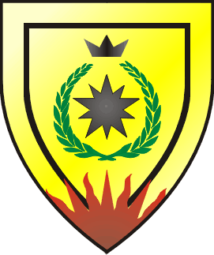 | Order of the Golden Bridle   | Given to those who have striven to further both their skill on the Equestrian field and the Equestrian Arts, who are involved in the arts and basic heraldry, display courtly graces and manners, and chivalrous conduct on and off the field. The insignia is a braid of green, white and gold cords, tied to a brass ring. | None
 | Order of the Golden Lance | Given to those equestrians who have distinguished themselves by demonstrating exceptional skill, leadership and honor on the equestrian field; service to Ansteorra and its people; knowledge of the courtly graces; and who have shown a consistent respect for the laws and customs of Ansteorra. A ribbon sable edged Or charged with a lance Or worn on either calf or above either elbow. | Grant

Meridies   | Order of the Argent Lance   | Given to those equestrians who have displayed courteous and chivalrous conduct, and who have distinguished themselves in the field of equestrian sciences. Members may place the initials ALM after their names, and may carry on their tournament lances a small black pennon bordered in white, bearing an uncial `M' above a white tilting lance, whenever engaged in equestrian activities. The badge of the order is Sable, in pale an uncial M and a tilting lance argent. | No
 | Companionate of the King’s Lancer   | Given to those who have served the Kingdom in the capacity of King's Lancer. The King's Lancer leads and organizes the Royal Horse Guard. Election into this order rests solely with His Majesty and is given to those who have shown outstanding horsemanship in winning the King's Lancer Equestrian Tournament. Members are elected only once to the order, though they may serve the Kingdom as King's Lancer upon more than one occasion. Members may place the initials CKL after their names. The badge used by the King's Lancer and members of the companionate is: Checky sable and argent, a knight armed cap-a-pie mounted upon a horse courant to sinister a bordure embattled Or. | No
Atlantia  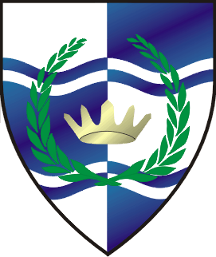 | Order of the Quintain  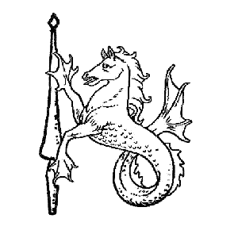 | Honors and recognizes those who have distinguished themselves and shown excellence in the pursuit of equestrian activities, in service or valor. | Award of Arms
 | Order of the Golden Lance  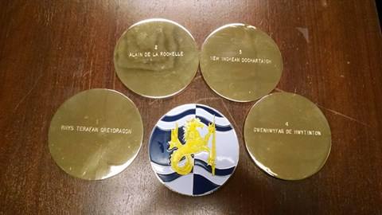 | (treaty with Ansteorra) honors and recognizes those subjects who have demonstrated exceptional expertise in the arts of equestrian activities and who have, through service to the equestrian community, advanced those arts and promoted them. The Order of the Golden Lance of Atlantia was created as a GoA level polling order on September 24, 2011 by Michael IX and Seonaid VII. The first Golden Lance of Atlantia was given on September 24, 2011 to Rhys Terafan Greydragon by TRM Michael IX and Seonaid VII. | Grant of Arms
An Tir  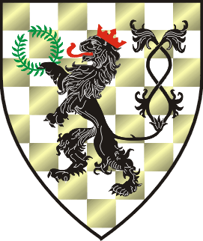 | Lion et de la Lance  (Heraldry pending) | Membership carries a Grant of Arms and is awarded by the Crown given for excellence and chivalry in the pursuit and practice of the equestrian arts. | Grant of Arms
Calontir  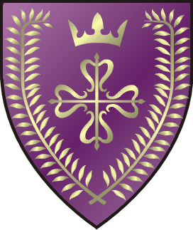 | Eo-Fyrd | Elevation to the Eo-Fyrd may be conferred upon those individuals meeting certain requirements; including authorizations in general riding, mounted games, and as a groundsman, and who display proficiency in at least two equestrian games, demonstrate support for the Calontir army on the equestrian field, and whose conduct is consistently honorable both on and off the field. Fyrdmen of the Eo-Fyrd may bear the badge of the Eo-Fyrd, emblazoned: Sable, on a pile embattled between two broken snaffle-bits argent, a Cross of Calatrava purpure. | Award of Arms
 | Eo-Hirth | The Eo-Fyrd are those who are authorized in general riding, mounted games, and as a groundsman, who display proficiency in at least one equestrian weapon system. Other qualifications include demonstrating support for the Calontir Army on the equestrian field, and displaying consistently honorable conduct both on and off the field. Sable, on a pile embattled between two broken snaffle-bits in pile argent a cross of Calatrava purpure. | Grant of Arms

Trimaris   | Order of the Silver Saddle  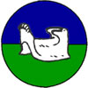 | Given to those equestrians who have demonstrated personal excellence in any aspect of the equestrian arts. The badge of the Order is Per Fess Azure and Vert, a Tournament Saddle Argent | No
 | Order of the Golden Lance  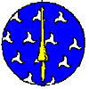 | Given to those equestrians who have distinguished themselves by demonstrating exceptional skill, leadership and honor on the equestrian field; service to Trimaris and its people; knowledge of the courtly graces; and who have shown a consistent respect for the laws and customs of Trimaris. The badge of the Order is Azure Semy of Triskeles Argent, a lance Or. | Grant of Arms
Outlands  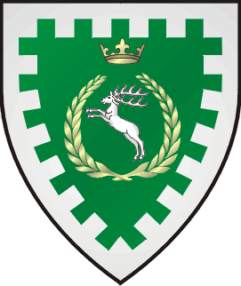 | Order of the Silver Stirrup   | Given to those equestrians who have demonstrated their abilities in service to the kingdom. Companions of the Silver Stirrup are entitled to place the initials CSS after their names. | Award of Arms
 | Order of the Silver Lance  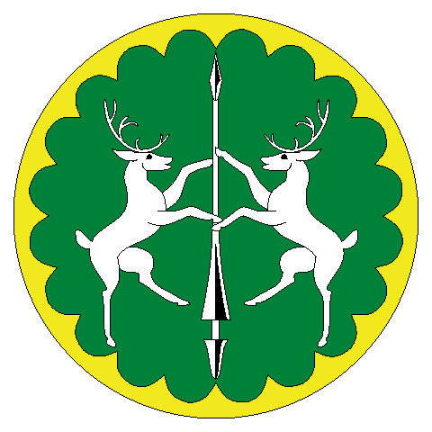 | Given by the Crown to those persons who have demonstrated exceptional skill and leadership in the equestrian arts. Other qualifications shall include leadership, activity level and teaching. Said individuals must also display unquestionable honor both on and off the field. The holders of this award shall be styled as a Lancer of the Outlands and shall be entitled to place the initials OLO after their names. Vert, two stags combatant sustaining between them a lance argent, a bordure engrailed Or | Grant of Arms
Drachenwald  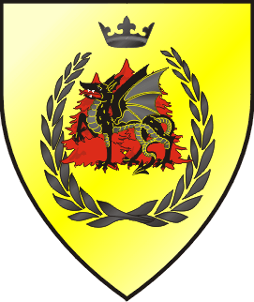 | None | None | None
Artemisia  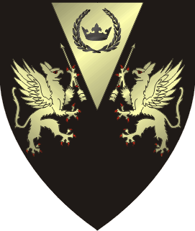 | Cheval d’Or  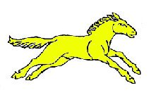 | Given to those gentles to acknowledge their excellence in the demonstration, education and execution of the equestrian arts. The bearers of this award shall be styled as Companions of the Cheval d'Or and shall be entitled to place the initials CdO after their names. The insignia of the Order shall be a medallion bearing a horse's head erased within a border of knots. The badge of the order is A horse courant contourny Or | Award of Arms
 | Order of the Bridle | Given for excellence in equestrian activities and the teaching of those skills. | Grant of Arms

Aethelmearc  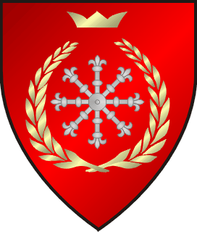 | 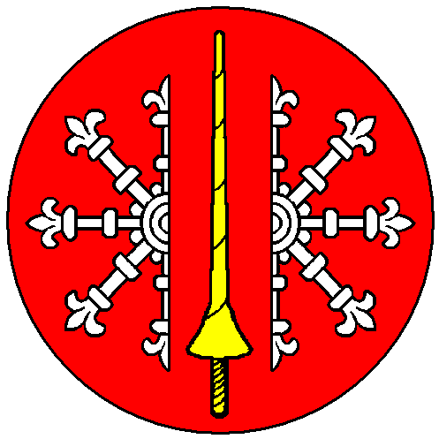  Order of the Golden Lance | (treaty with Ansteorra, etc)  Given to recognize accomplishments in the equestrian arts. The badge of the order is: Gules, a lance Or between two demi-escarbuncles palewise addorsed argent. | Grant of Arms
Ealdormere  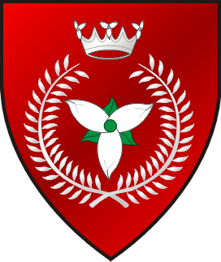 | None | None | None
Lochac  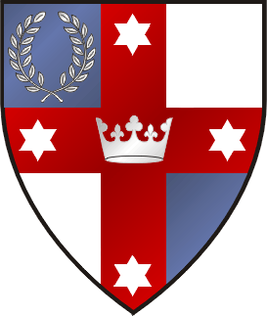 | Order of the Hector | The Order of Hector may be bestowed upon those the Crown of Lochac finds deserving of honour for excellence in equestrian activities. The Order confers an Award of Arms to the bearer, if they are not already armigerous. The registered badge for this company is “Gules, a horse’s head couped within a bordure wavy Or.” | Award of Arms
Northshield  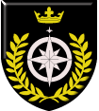 | Order of the Palfrey | Given to those who demonstrate prowess and chivalry in equestrian activities, including a level of participation beyond their personal endeavors. | Award of Arms
 | Order of the Destrier | Given to those who have, over time, demonstrated great prowess, chivalry, and leadership in the Equestrian Arts. Members are expected to continue conspicuous activity in the Equestrian Arts, and to encourage others to become involved and proficient. | Grant of Arms
Gleann Abhann  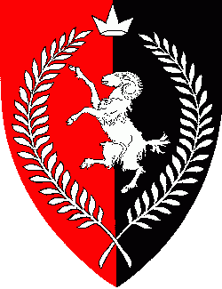 | none | none | none
Avacal  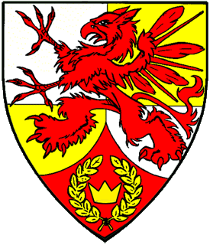 | Order of the Red Horse  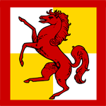 | Given for excellence in equestrian activities within Avacal, and demonstrating a leadership role in equestrian activities, including the willingness to teach. | Grant of Arms

